**Farfield Boxers**

**Established 1955**

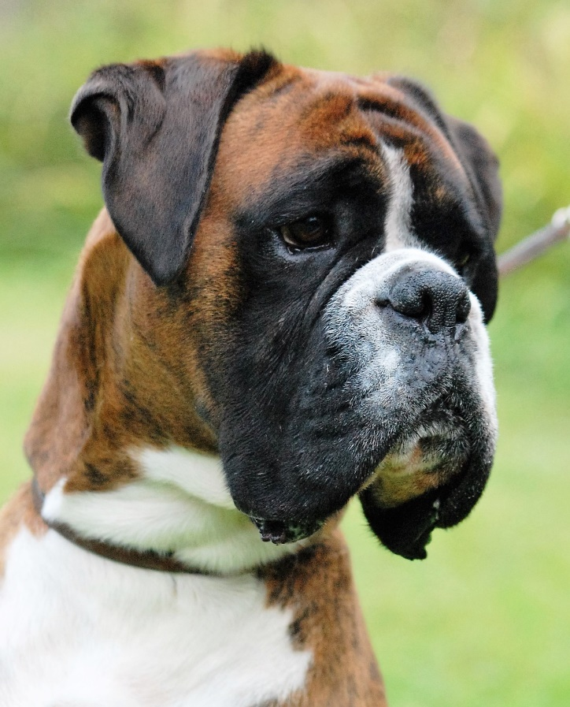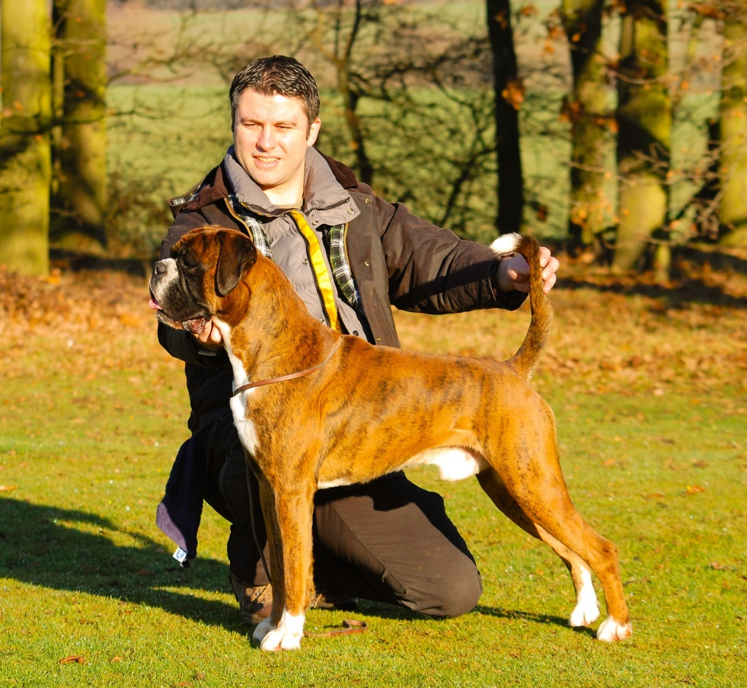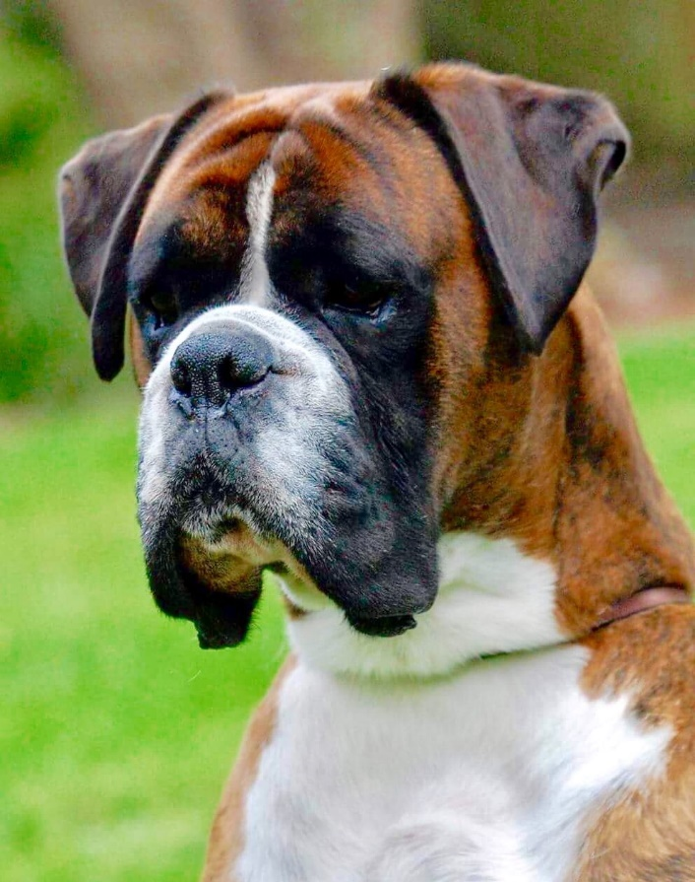

**ABOUT US**

 The Farfield affix was established by my late father Les Whitfield in 1955. In the early 1990’s my Dad and I shared the Farfield affix in partnership and I am very proud to be able to continue his legacy.

For over 60 years our kennel has strived to own and breed dogs that possess type, soundness, quality and character, and we are proud to have produced champions and ticket winners along the way!

​

We are a small and select kennel and currently have the pleasure of campaigning Panabolo Strike a Deal with Farfield ‘Max’ who continues to fly the flag for us in the show ring with great success. Max lives with us at home in Brentwood, Essex, along with his son, Marley.

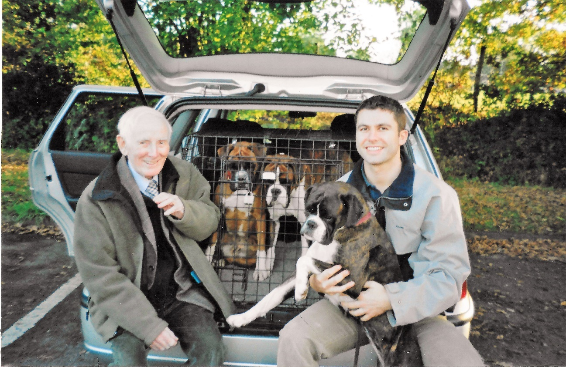

We hope you enjoy our website!

**Max and Marley, our current Boxer family**

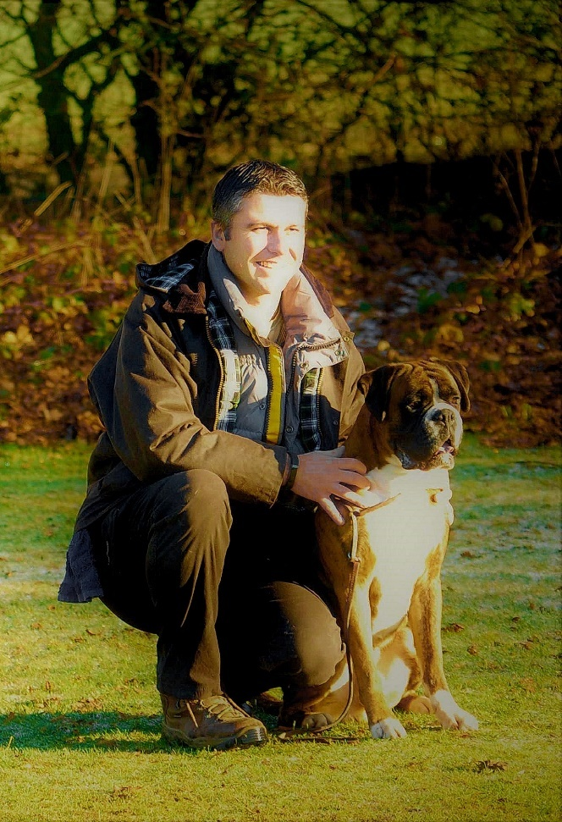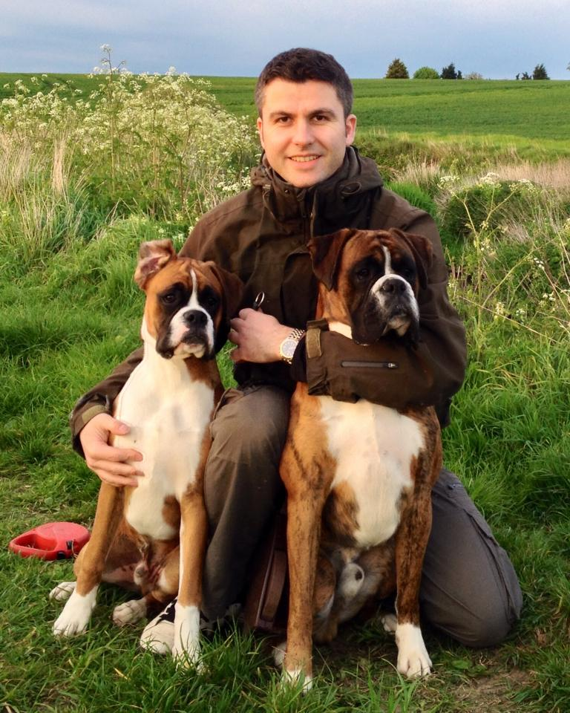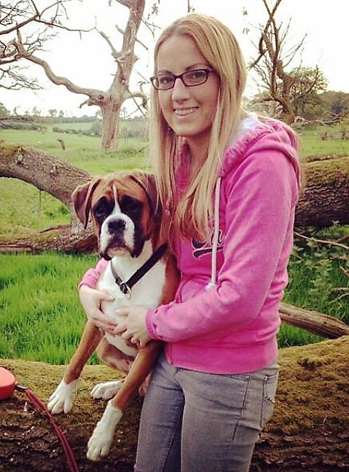

**AT STUD**

**Panabolo Strike a Deal with Farfield**

**‘Max’**



Confidently offered at stud

Max sires both reds and brindles and is [heart tested ‘0’ (clear)](http://www.boxerbreedcouncil.co.uk/dogmp.asp)

For stud enquiries please call me on 07771 661974 or email [farfieldboxers@gmail.com](mailto:farfieldboxers@gmail.com)

**Max’s pedigree**

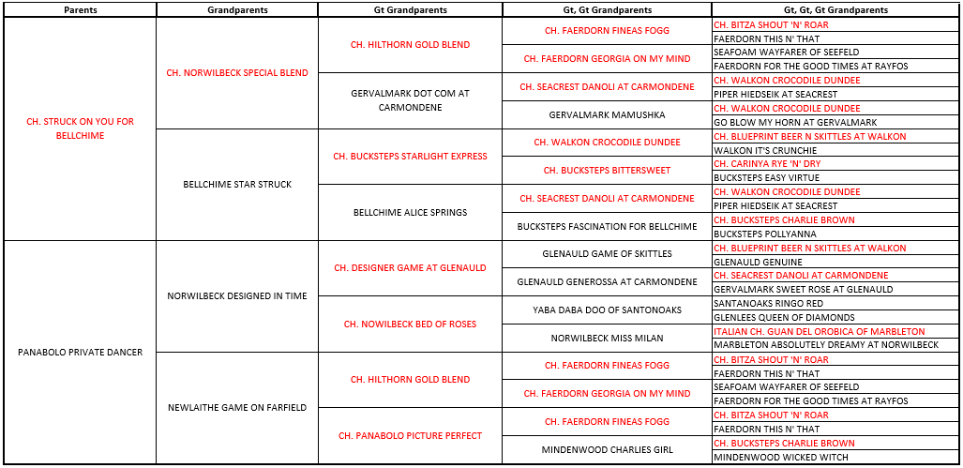

**Typical puppies sired by Max**

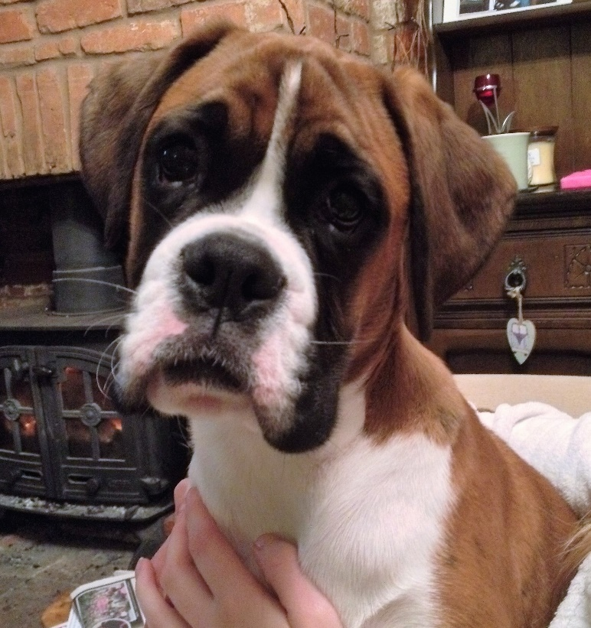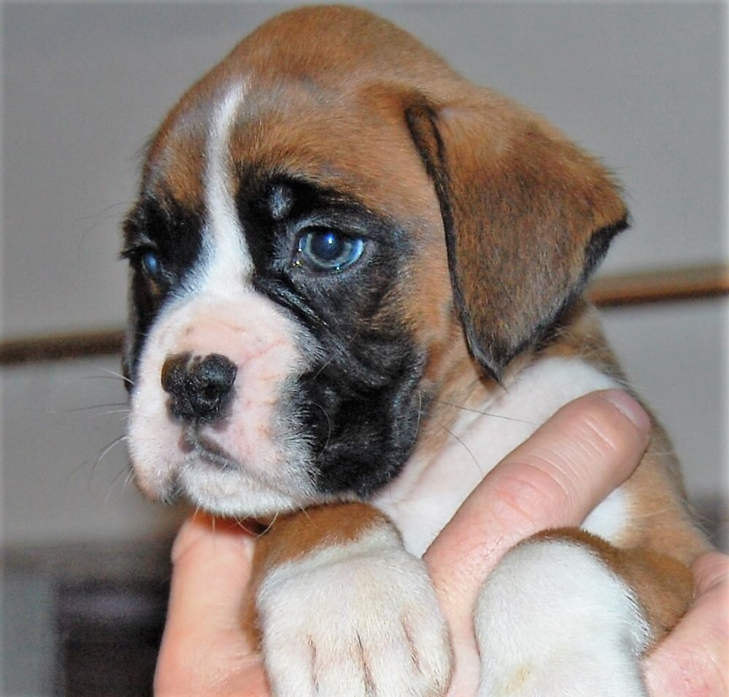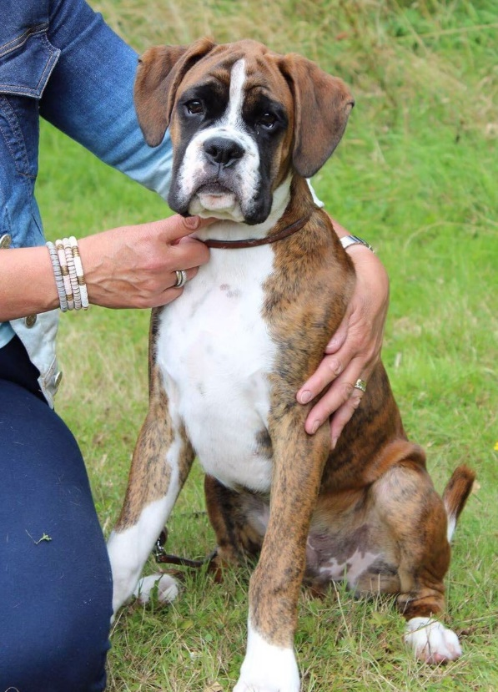 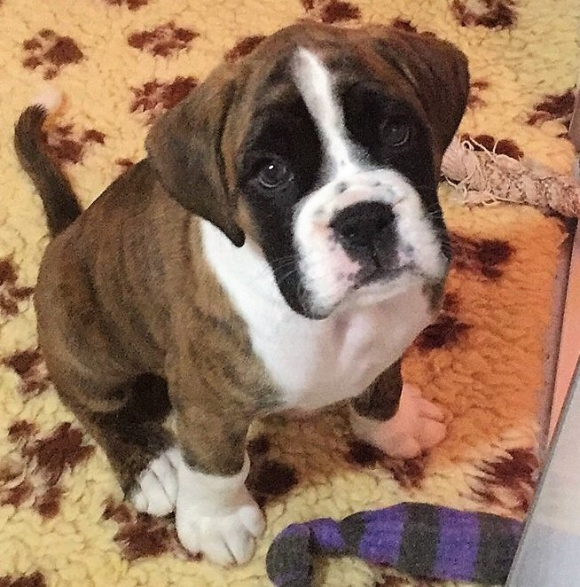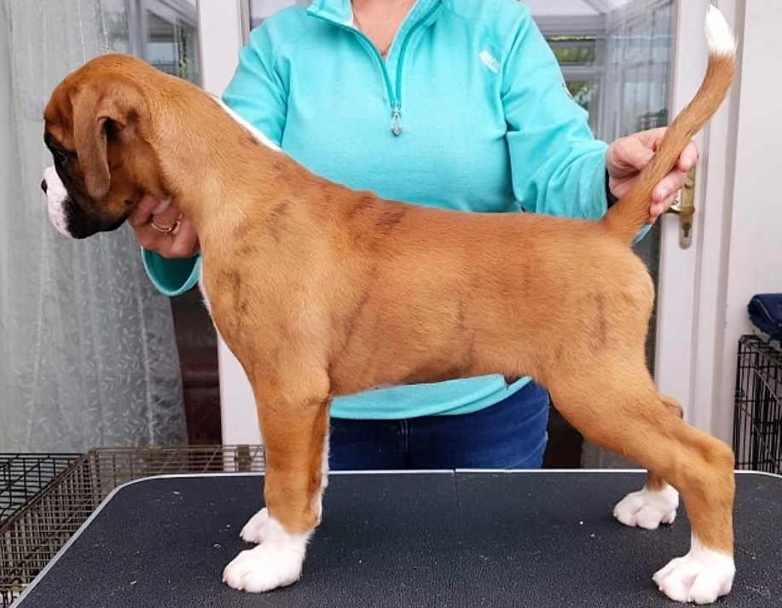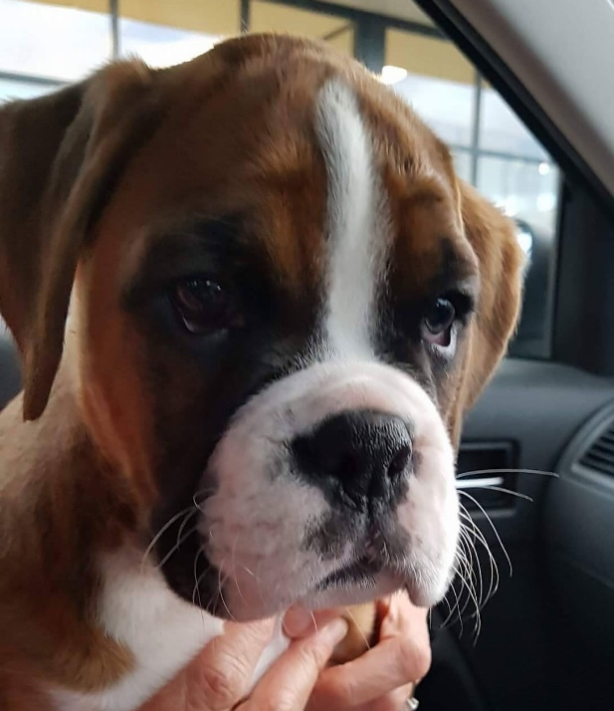

**We are very proud of Max’s successes in the showring…**

Max winning Best in Show at the Essex and Eastern Boxer Club.

Judge: Vikki Van Beck (Newlaithe)

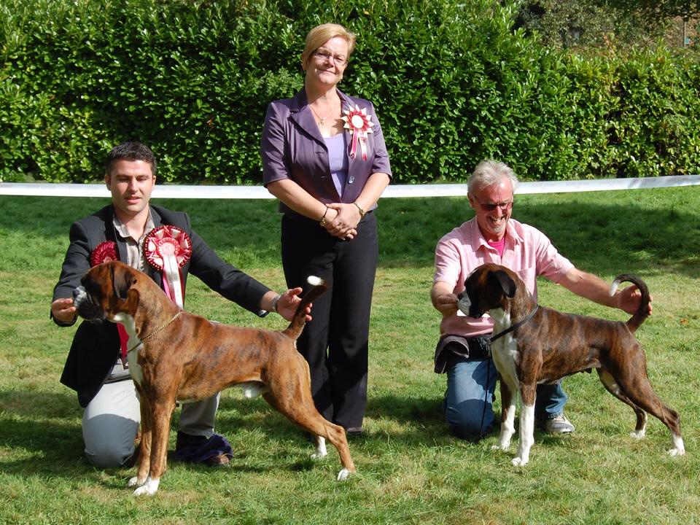

Max winning Best in Show at the London and Home Counties Boxer Club.

Judge: Maggi Bryant (Panelma)

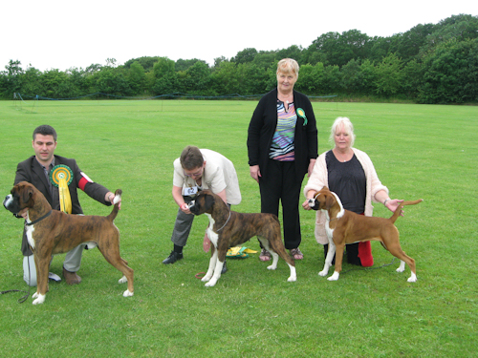

Max winning Best in Show at the London and Home Counties Boxer Club. Judge: Sarah Portlock (Sheiken)

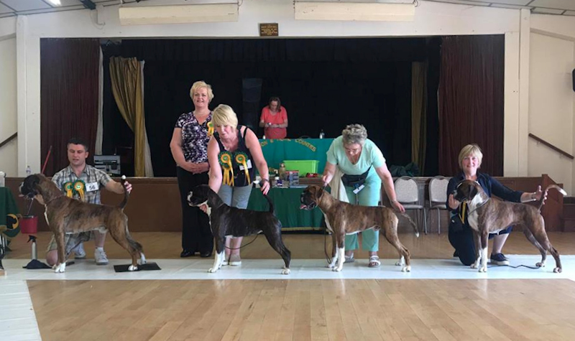

**Farfield Champions and ticket winners**

**Champion Farfield Mayfly of Skelder , winner of 3CCs, 3RCCs**

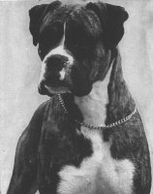**Born**: 30 Mar 1967   
**Sex**: Bitch  
**Colour**: Brindle, White Markings  
**Sire**: Velvet Touch of Skelder  
**Dam**: Farfield Ting-a-Ling  
**Breeder**: Mr M L Whitfield  
**Owner**: Mrs J Malcolm  
**Date of Attaining Title**: 15 Jul 1969

Chris, there is a link to a site that has HTML for this pedigree that I hope we can use - please can you display the pedigree underneath? (**http://www.boxerpedigrees.info/pedigree_htmlcode.php?id=70976&gens=4)**

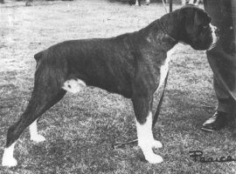**Champion Farfield Pedro, winner of 3 CCs**

**Born**: 2 Jul 1968   
**Sex**: Dog  
**Colour**: Brindle, White Markings  
**Sire**: [CH Wardrobes Huntersmoon](http://www.ukboxerdogs.co.uk/britchamp1966.html#wardrobes_huntersmoon)  
**Dam**: Radden Ailsa Amaryllis  
**Breeder**: Mr W L Whitfield

**Owner**: **Major**John R Nicholls  
**Date of Attaining Title**: December 1970 at Richmond

Chris, there is a link to a site that has HTML for this pedigree that I hope we can use - please can you display the pedigree underneath? (<http://www.boxerpedigrees.info/pedigree_htmlcode.php?id=70989&gens=4>**)**

**Champions abroad - bred at Farfield**

**Australian Champion Opportunity Knocks from Newlaithe** (Ch. Burnden Opportunist x Newlaithe Game On Farfield)

Owned by Sue and Brian Mckie of Bockson Boxers

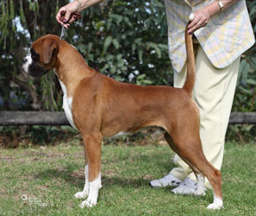

**South African Champion Farfield Springtime** – who gained her title in 1970, owned by Shirley and Ian Fraser-Ker

**South African Champion Farfield Volley**

**Farfield Lavender Girl**

Winner of many RCCsbehind Champion Wardrobes Claire de Lune

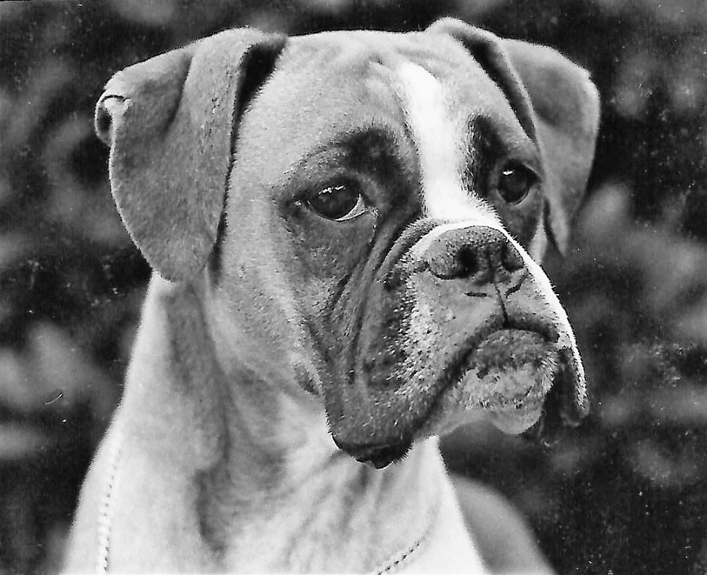 **Born**: 2 Jul 1968  
**Sex**: Female  
**Colour**: Red, White Markings  
**Sire**:  [CH Wardrobes Huntersmoon](http://www.ukboxerdogs.co.uk/britchamp1966.html#wardrobes_huntersmoon)  
**Dam**: Radden Ailsa Amaryllis

**Breeder**: **Les Whitfield**

**Owner**: **Les Whitfield**

**Farfield Bamarhill Full Cry – 1 RCC**

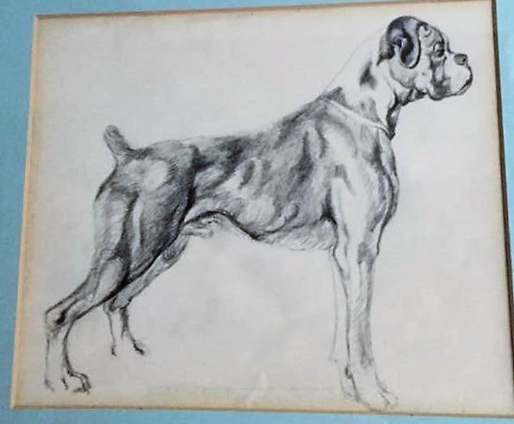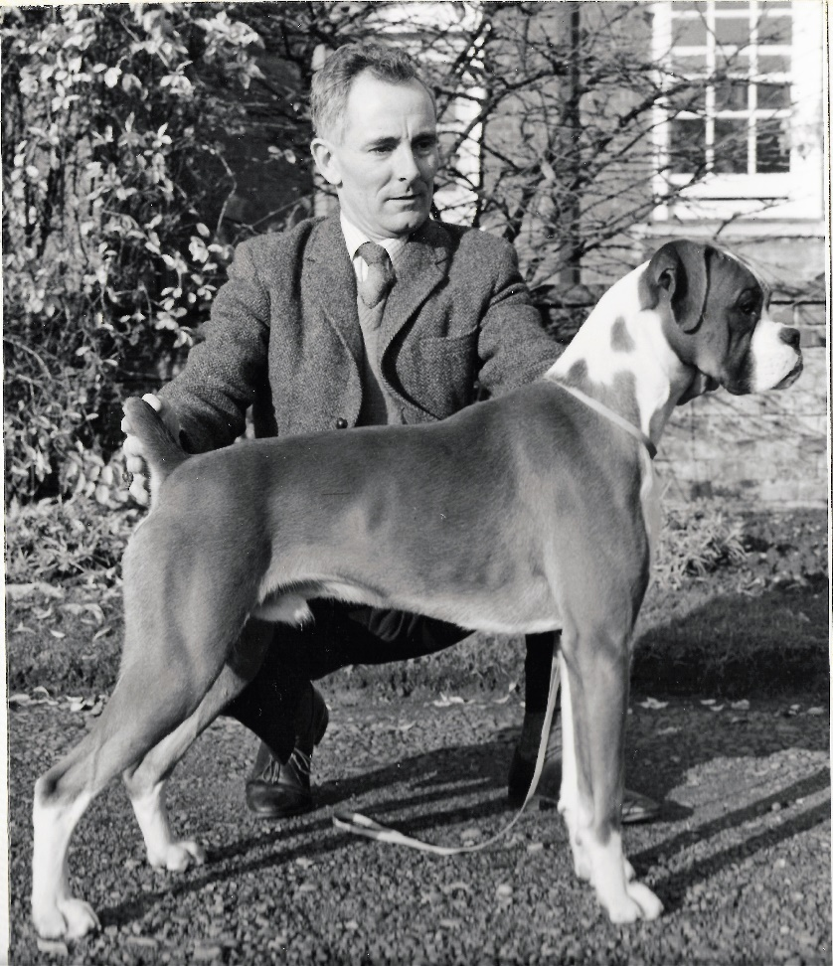**Born**: 21st Dec 1967  
**Sex**: Dog  
**Colour**: Red, White Markings  
**Sire**: [CH Wardrobes Huntersmoon](http://www.ukboxerdogs.co.uk/britchamp1966.html#wardrobes_huntersmoon)  
**Dam**: CH Bamarhills Golden Quest  
**Breeder**: Mrs. D H Hillson

**Owner**: **Les Whitfield (later owned by Joy and Roger Cross)**

Pedigree Chris, there is a [link to a site that has the html for you to embed the pedigree](http://boxerpedigrees.info/pedigree_htmlcode.php?id=81671&gens=4)

**Whytebarton Signal at Farfield , 1 RCC**

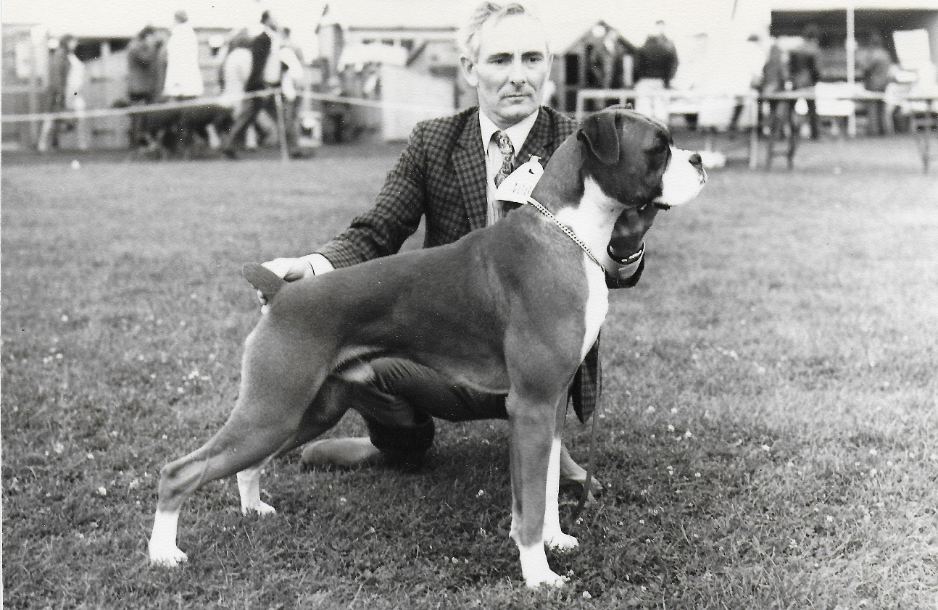**Born**:   
**Sex**: Dog  
**Colour**: Red, White Markings  
**Sire**: Farfield Bamarhill Full Cry  
**Dam**: Whytebarton Seeker

**Breeder**: Mrs. D H Hillson

**Owner**: **Les Whitfield**

**Farfield Flower Girl , 1 RCC**

**Born**:   
**Sex**: Female  
**Colour**: Red, White Markings  
**Sire**: 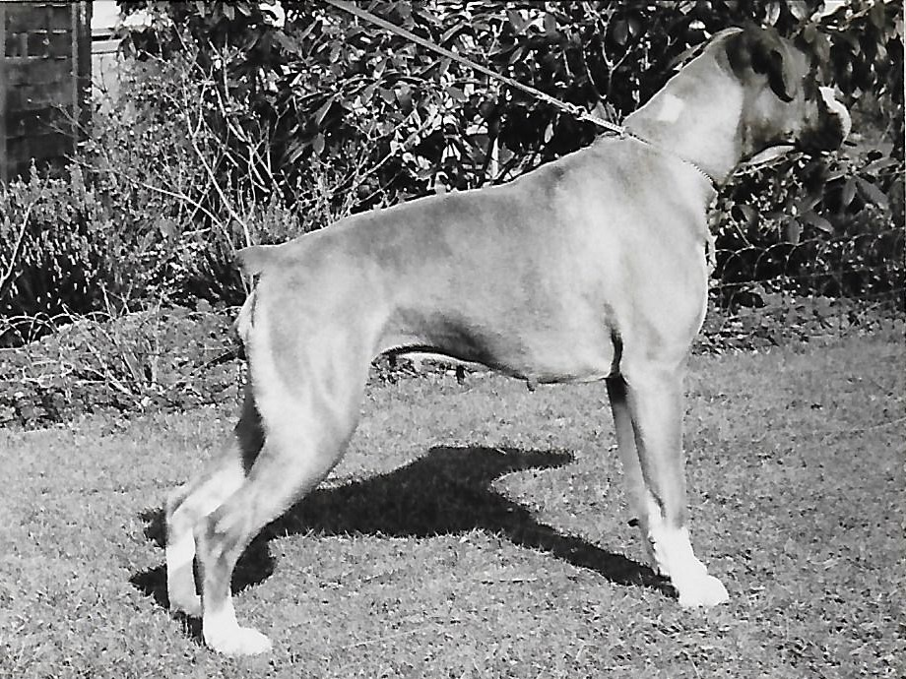Farfield Bamarhill Full Cry

**Dam**: Wardrobes Moonlight Echo

**Breeder**: **Les Whitfield**

**Owner**: **Les Whitfield**

**Wardrobes Farfield Sparkler, 1 RCC** (sold to the famous Wardrobes boxers)

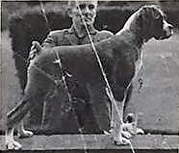Photo at 5 months

**Born**: Mar 1970  
**Sex**: Male  
**Colour**: Red, White Markings  
**Sire**: Ch. Farfield Pedro

**Dam**: Wardrobes Moonlight Tango

**Breeder**: **Les Whitfield**

**Owner**: **Connie and Wilson Wiley**

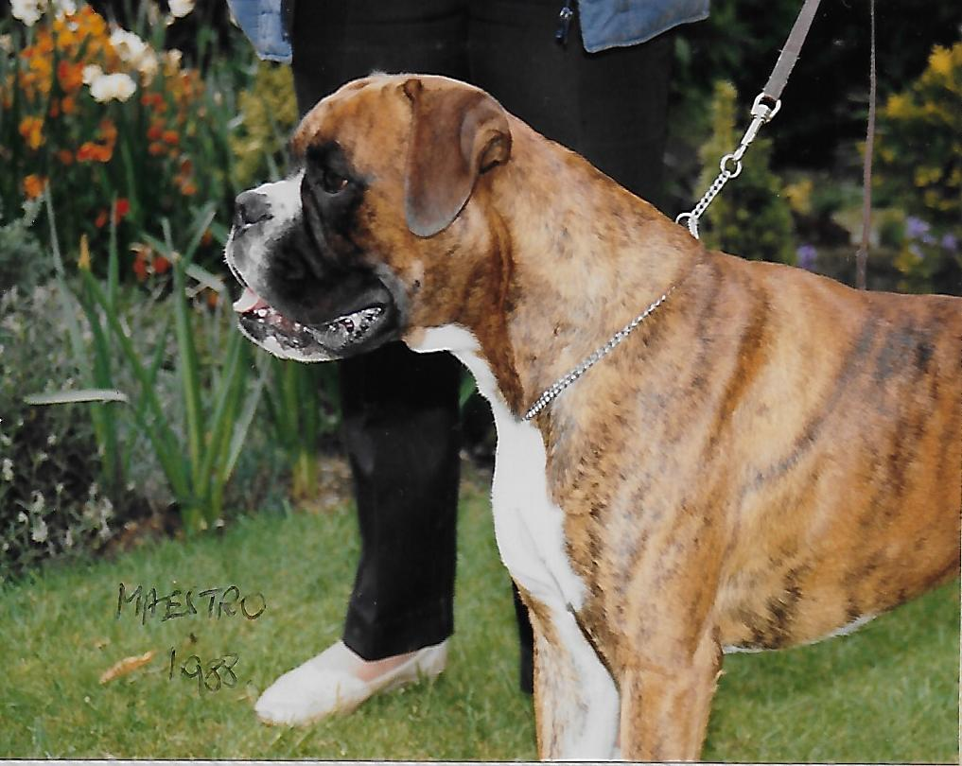**Farfield Maestro at Sandyne**, 1 RCC Chris, there is a [link to a site that has the html for you to embed the pedigree](http://www.boxerpedigrees.info/pedigree_htmlcode.php?id=85109&gens=4)

**Born**: Aug 1986  
**Sex**: Dog  
**Colour**: Brindle, White Markings  
**Sire**:  Wardo v Dommeldal of Tyegarth  
**Dam**: Benbrook Andante of Farfield  
**Breeder**: Mr W L Whitfield

**Owner**: **Edna and Den Woods**

**Farfield – past and present and memorabilia**

**(Chris – if you could display these pages in a cool way that would be great!)**

**T**he beginnings… **Juno by Worth** – Born in 1953, ‘Juno’ was the first ever Boxer owned by my Dad!

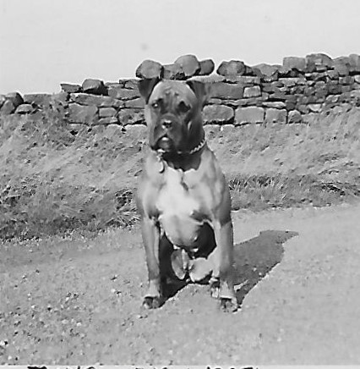 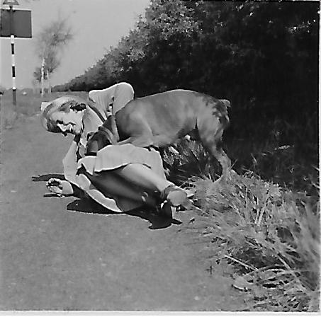 and knocking my Grandma over in true Boxer style en route to Southport!

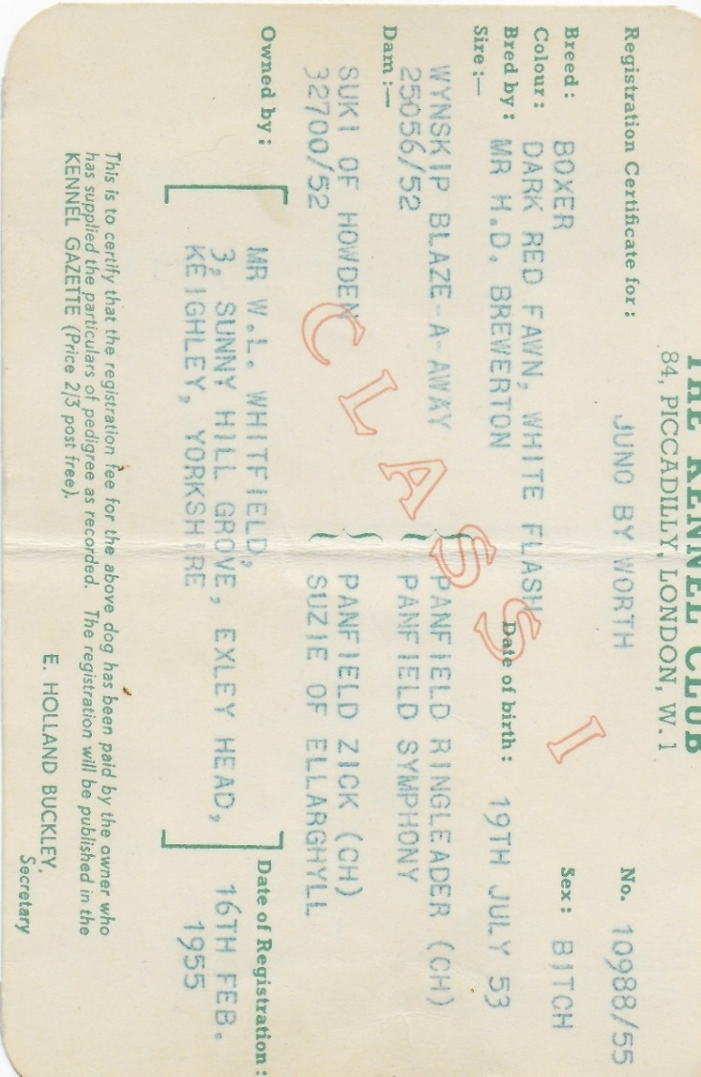

This is a what a Reserve challenge certificate looked like in 1969 – won by Farfield Lavender Girl, judge: Marjorie Clements

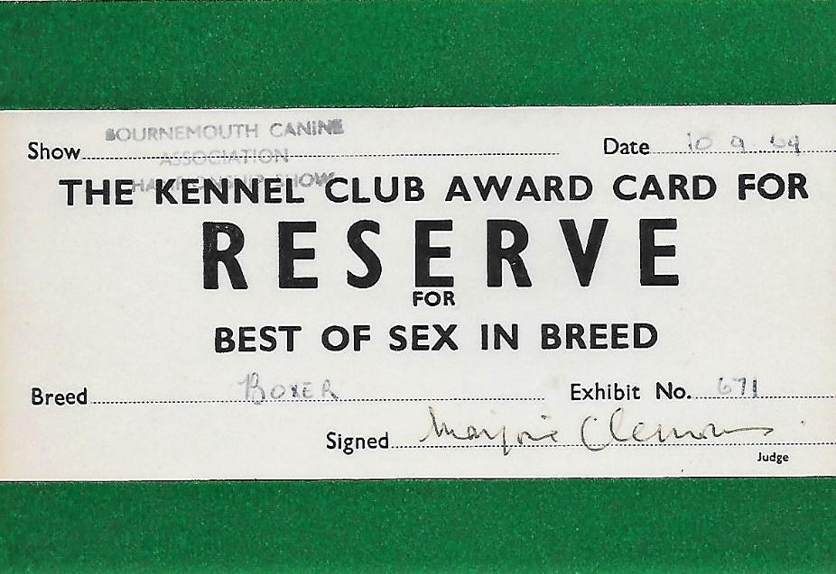 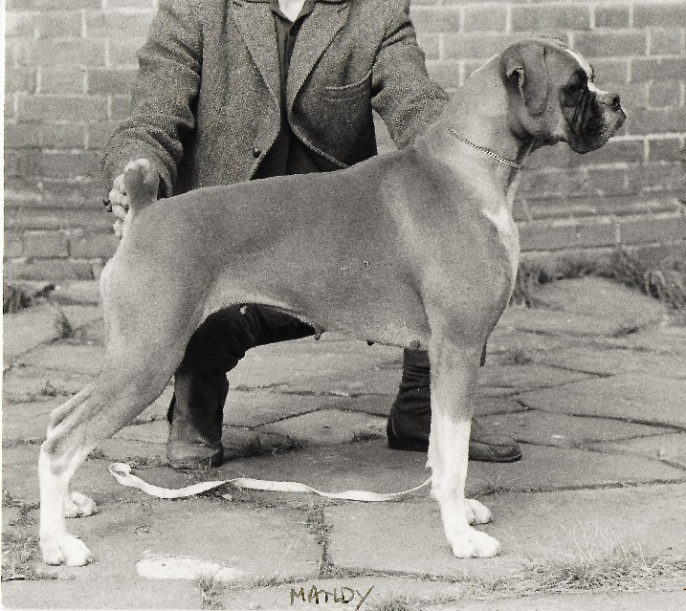

An advertisement from the early 1970’s!

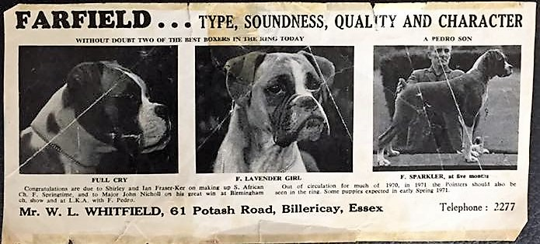

We also dipped our toe in other breeds!

Dad wins Best in Show with **C**ookrise Ena

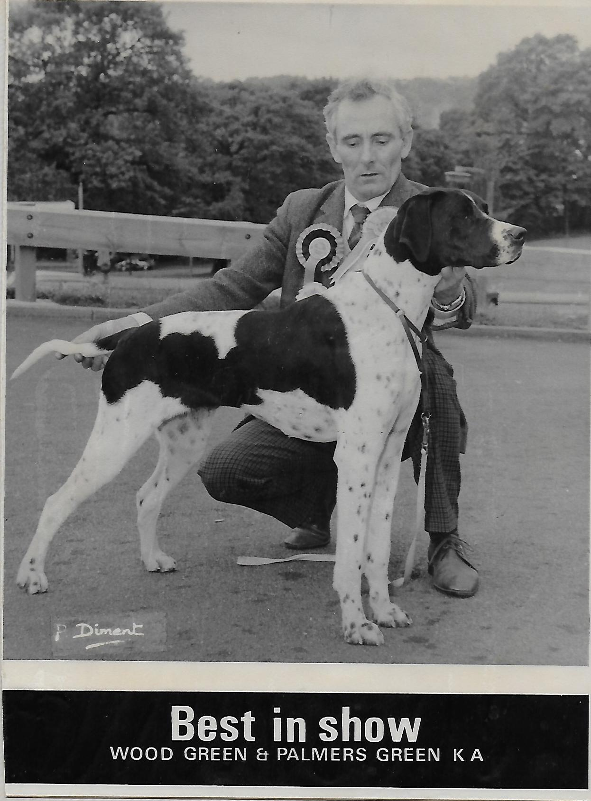

**Farfield Buccaneer of Shormana**

‘Paddy’ On his day could beat the best of them!

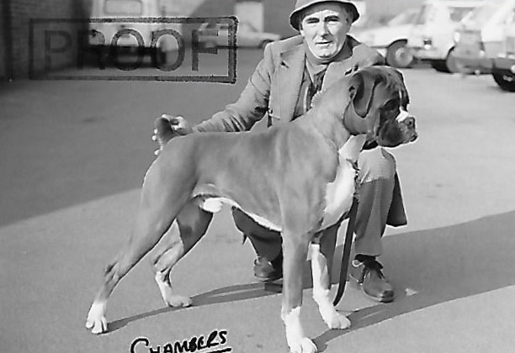**Born**: Mar 1980  
**Sex**: Male  
**Colour**: Red, White Markings  
**Sire**: Riddaghausen All Gold

**Dam**: Riddaghausen Royal Piper

**Breeder**: **Les Whitfield**

**Owner**: **Les Whitfield**

**Sparkle of Farfield -‘Twinkle’ (1986)**

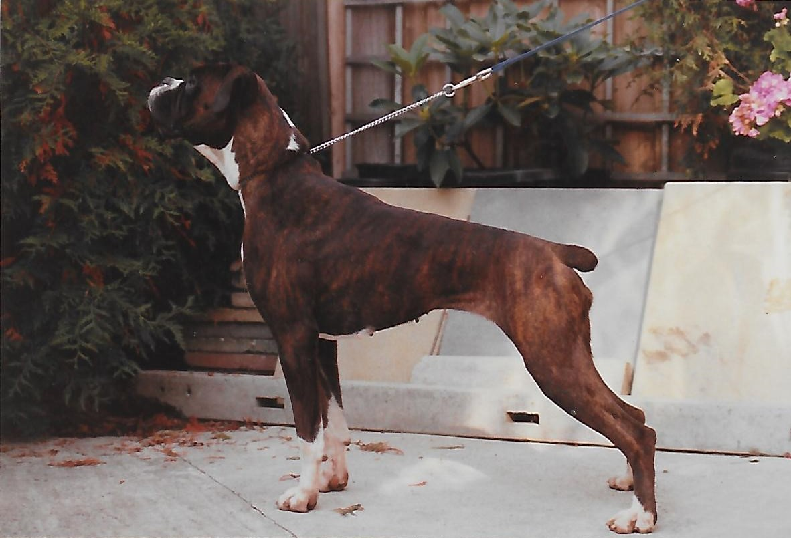**Born**: Mar 1985  
**Sex**: Female  
**Colour**: Dark Brindle, White Markings  
**Sire**: Dolf the Buhe-Farm of Marbleton

**Dam**: Moljon Velvet Touch

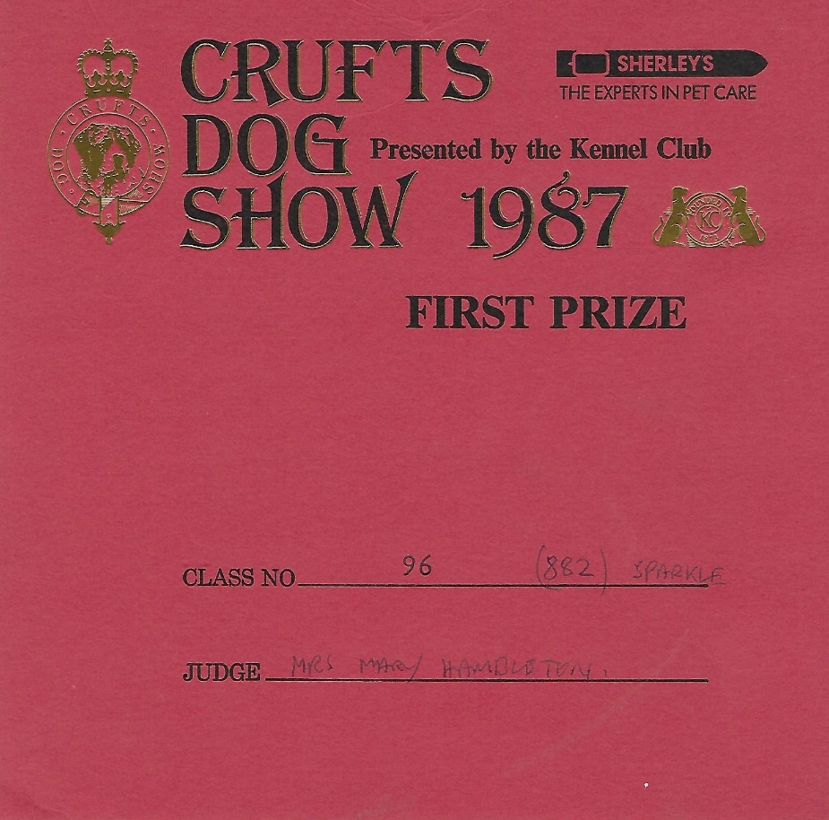

**Farfield Zest**

‘Tess’ was the dam of Mosaic of Farfield. Her sister ‘Touch of Mink at Telmonns’ was sold to Terry and Jean O’Connor who produced [Telmonns Dark Unique](http://www.boxerpedigrees.info/details.php?id=71314), sire of [Champion Sandyne Solo Dancer](http://www.boxerpedigrees.info/details.php?id=71313) amongst many other notable winners!

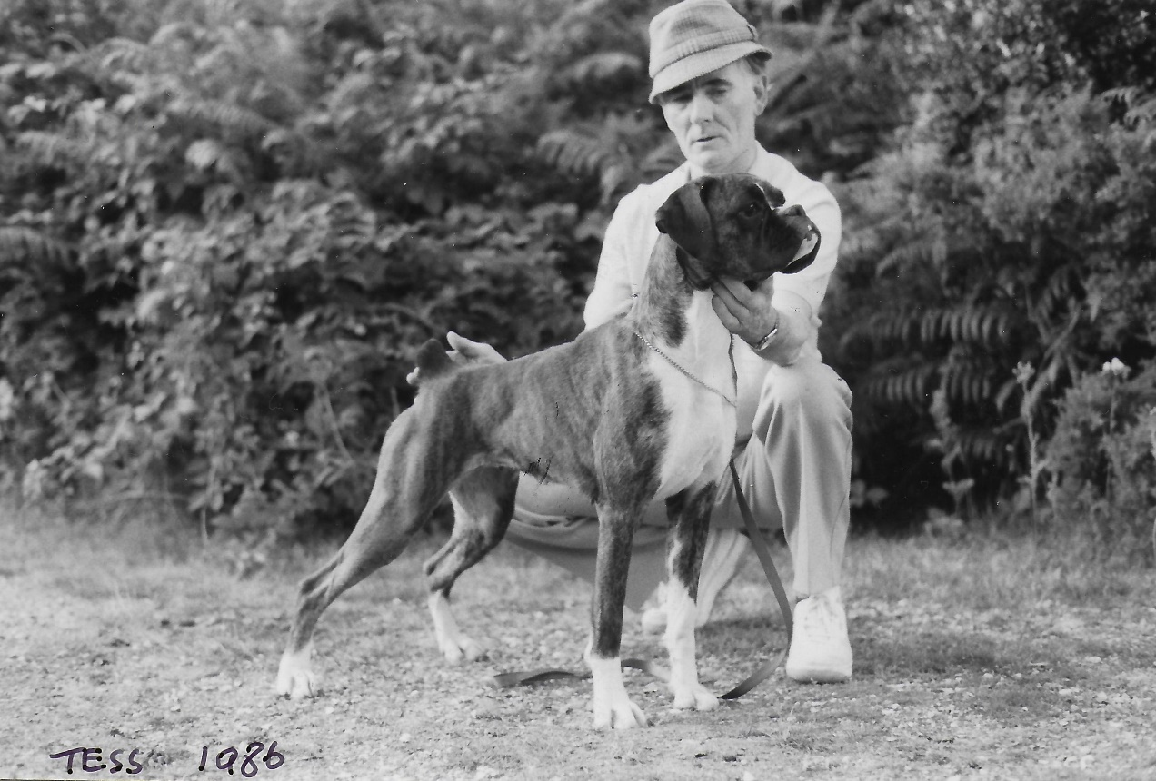 **Born**: 1985  
**Sex**: Female  
**Colour**: Brindle, White Markings  
**Sire**:  Ch. Sheffordian John-Joe  
**Dam**: Yooneek Pagan Lass from Farfield  
**Breeder**: Mr W L Whitfield

**Owner**: **Mandy and John Young**

**Mosaic of Farfield**

‘Joe’ - Although only lightly shown won Best in Show under John Hambleton (Marbleton) at the Essex and Eastern Boxer Club

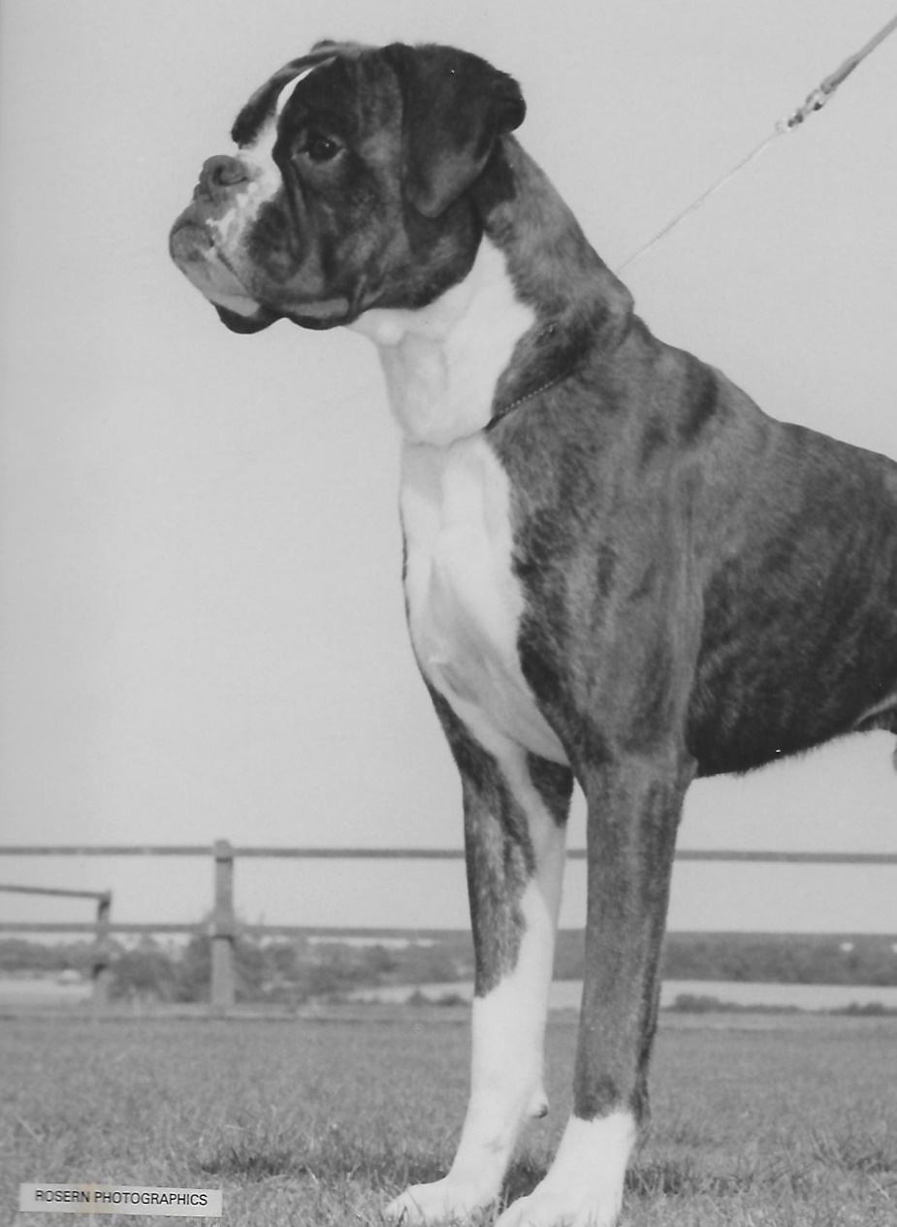 **Born**: 1987  
**Sex**: Male  
**Colour**: Brindle, White Markings  
**Sire**:  Wardo v Dommeldal of Tyegarth  
**Dam**: Farfield Zest  
**Breeder**: Mr W L Whitfield

**Owner**: **Mandy and John Young**

**Sunhawk Norwatch Sunshine at Farfield** (Ch. Tyegarth Famous Grouse x Ch. Sheffordian Ruby Tuesday of Norwatch)

‘Sunny’, my best friend when I was growing up and a big part of my life. She was full sister to Ch. Norwatch Sunhawk Raffles

Sunny with Helena Helping me revise for GCSE’s! Aged 11 years

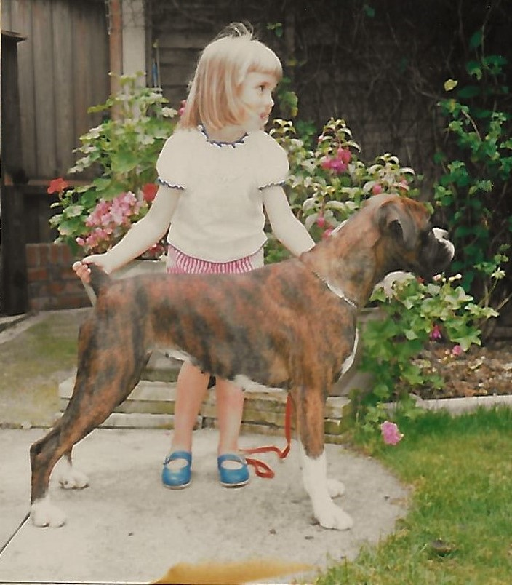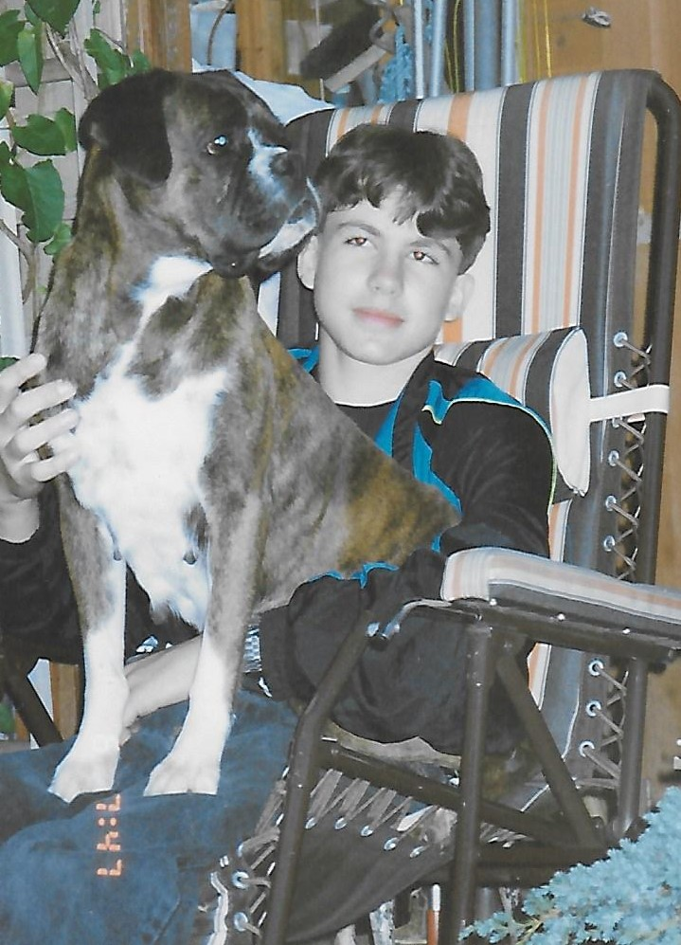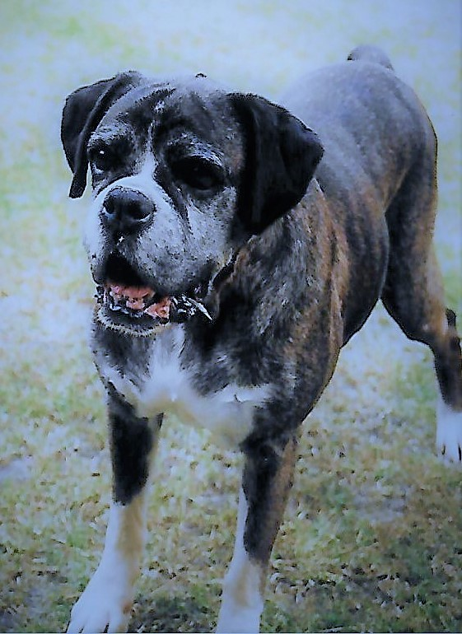

I only began showing Sunny properly as a veteran and she was extremely successful. She beat many champions and, along with my Dad, she can be attributed as being responsible for infecting me with the showing bug!

**Newlaithe Game On Farfield** (Ch. Designer Game at Glenauld x Louie Lila at Newlaithe)

‘Heidi’

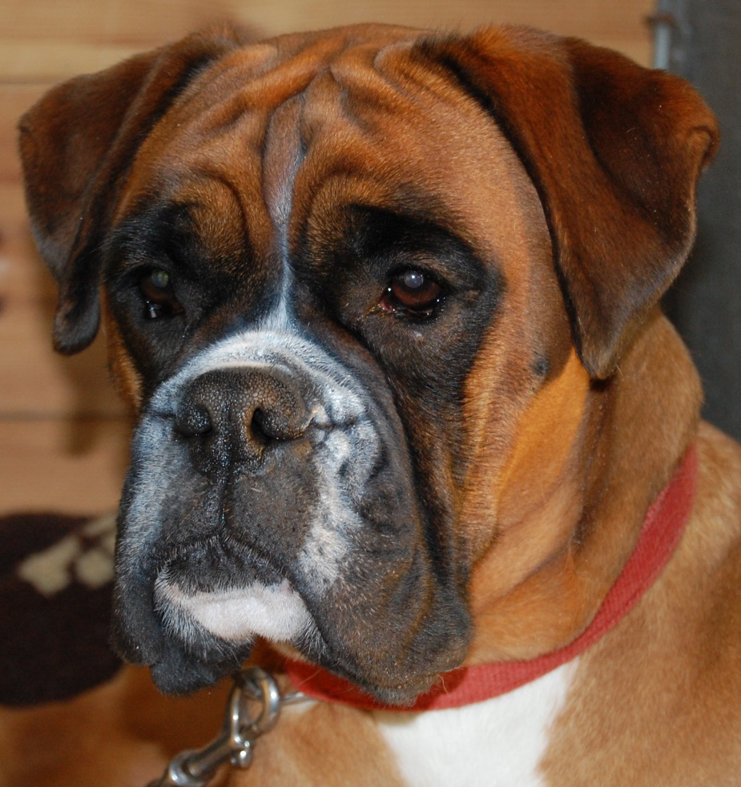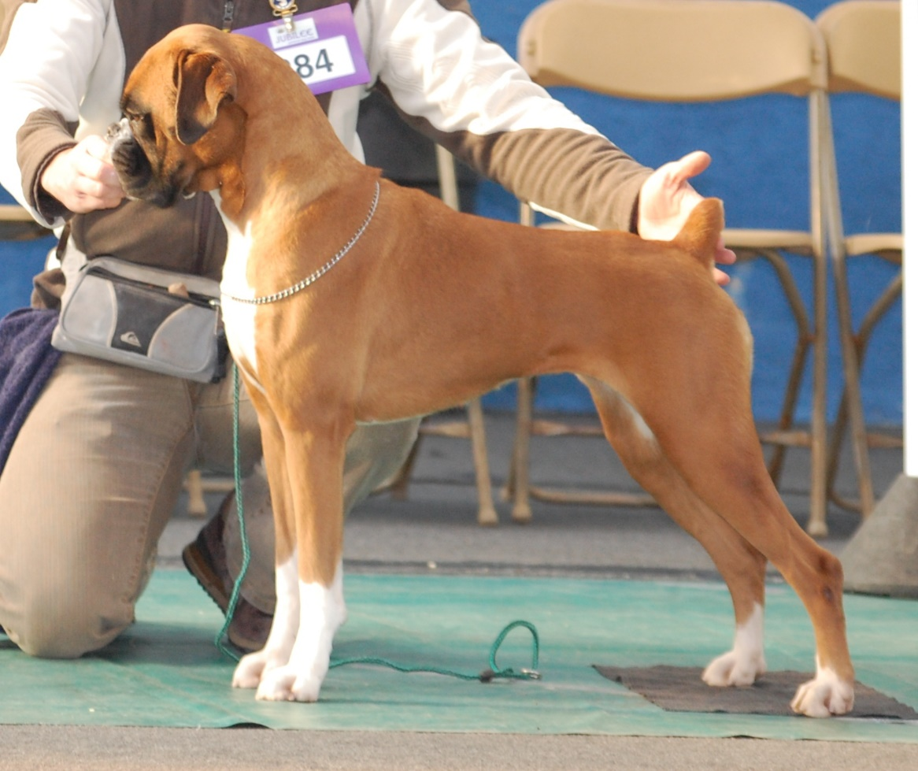

**Sulez Tempation at Farfield** (Ch. Seacrest Double Trigger from Glenfall x Ch. Sulez Labelled with Love)

‘Jaz’ was kindly sold to us by Sue Drinkwater. She was a little sweetie and never put a foot wrong. At one of her last shows Jaz won the Veteran class at Crufts in 2007 under Arthur Butters (Mindenwood).

Photographed here as a veteran!

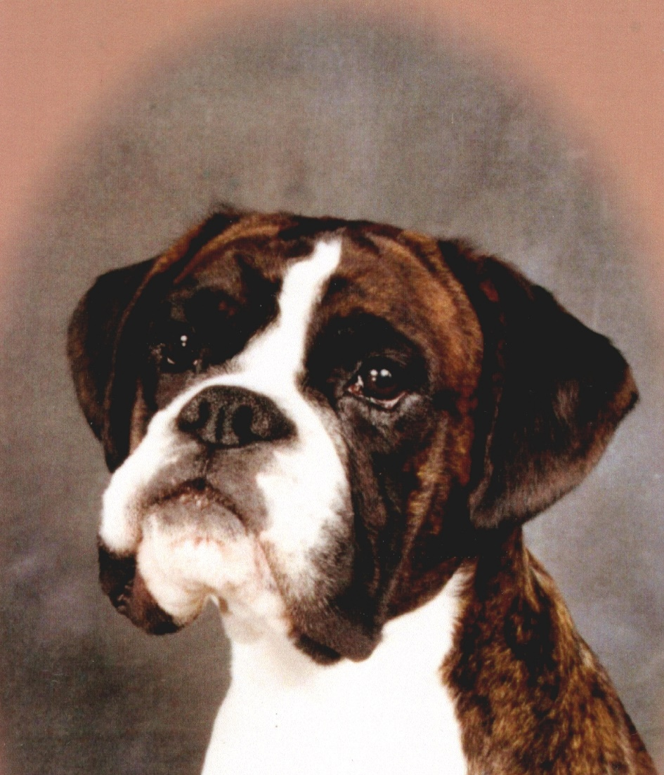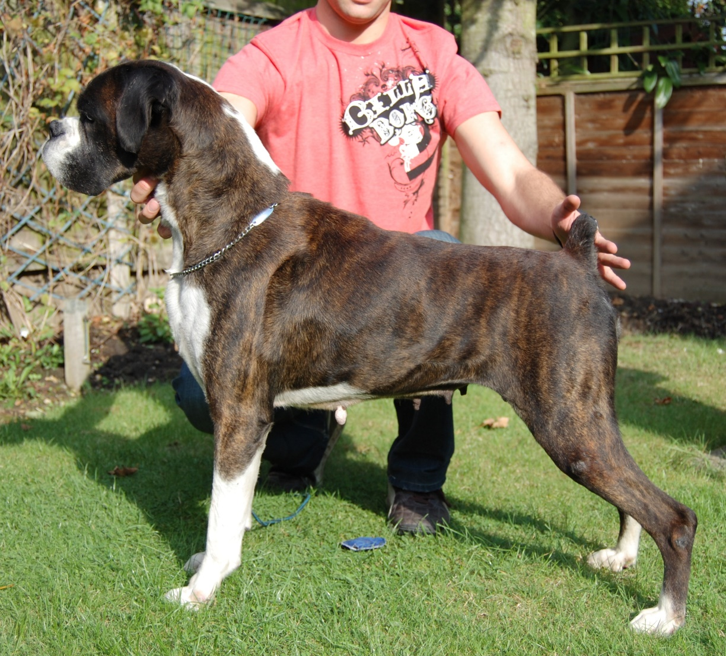

**Farfield Fallen Angel** (Ch. Winuwuk Lust in the Dust x Sulez Temptation at Farfield)

‘Penny’, although only lightly shown won Best in Show at the Essex and Eastern Counties Boxer Club amongst her many wins.

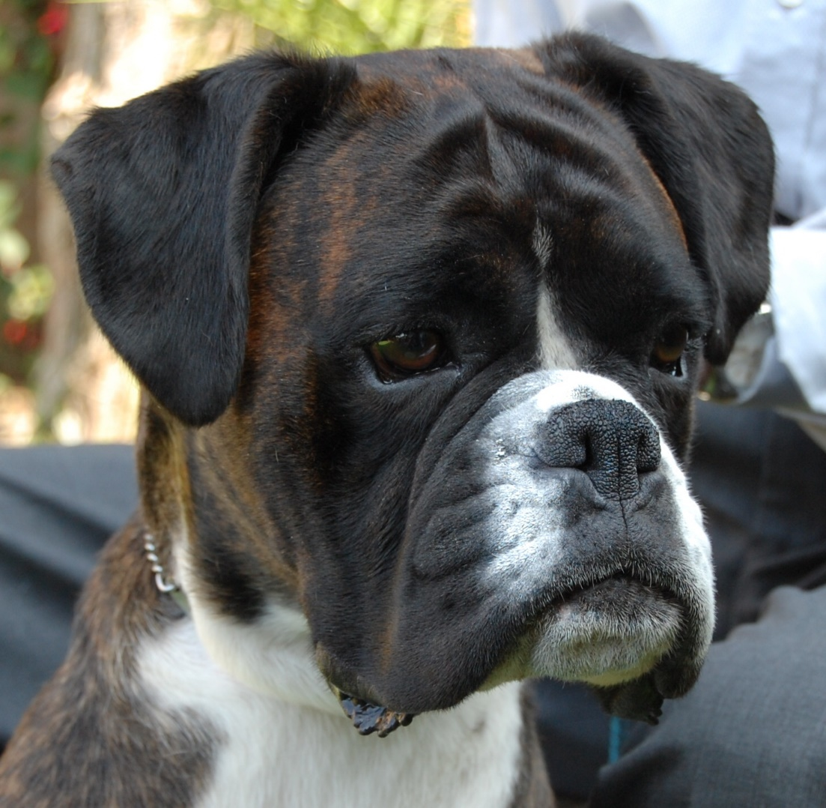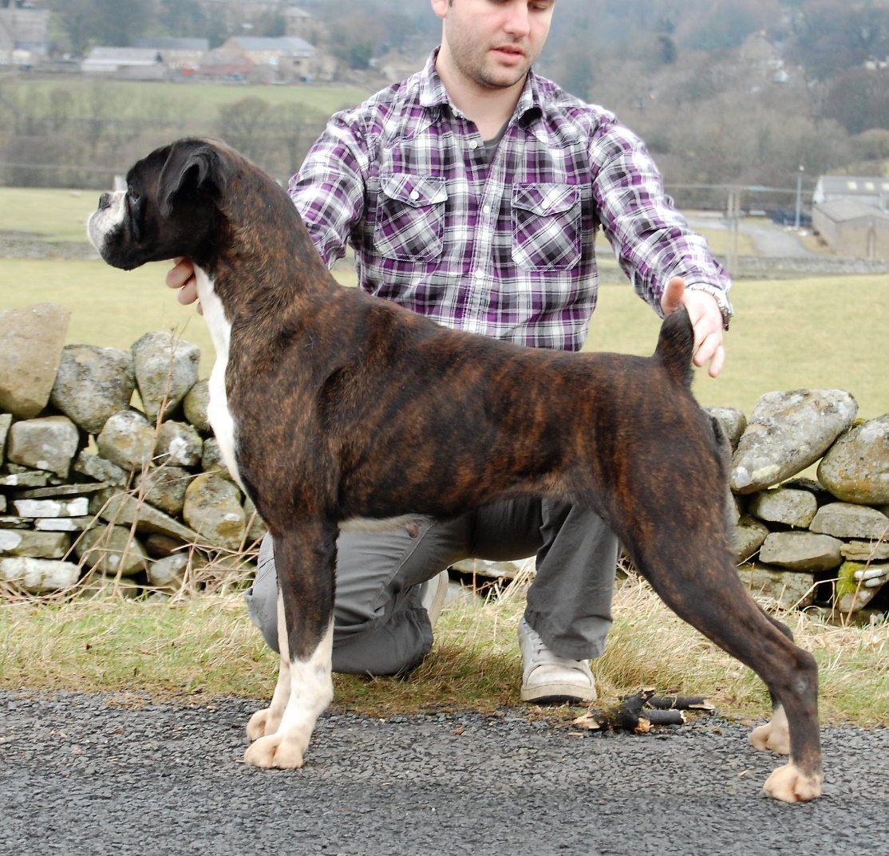

Penny was a little angel just like her mum and I was devastated to have to say goodbye to her.

**Panabolo Strike a Deal with Farfield** ‘Max’ winning his class at the Anglian Boxer club as a youngster.

Judge: Tony Lockwood-Brown

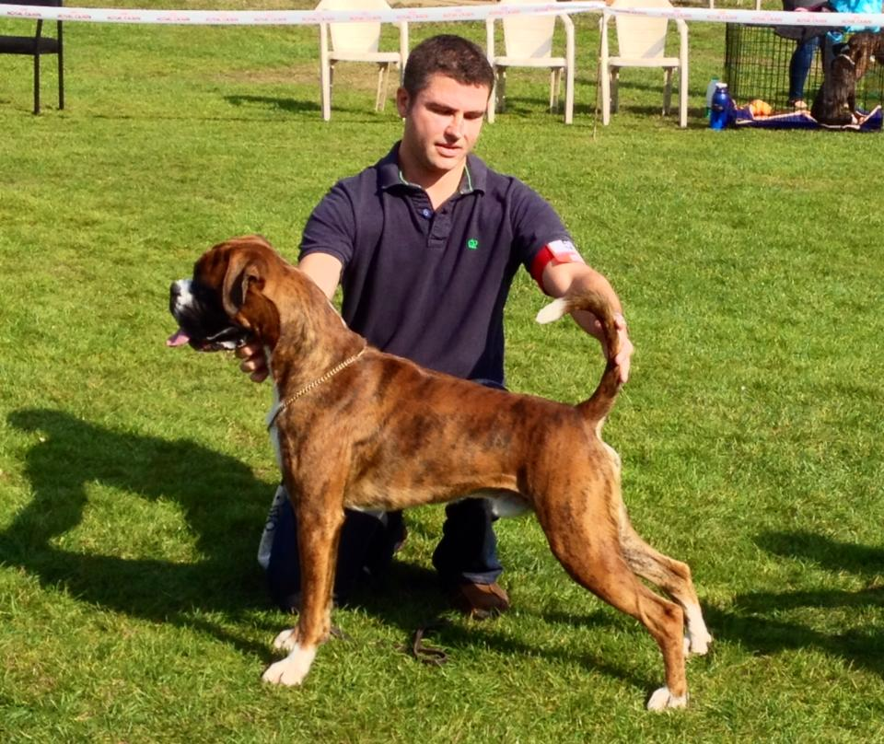

**Judging in the hey day!**

Ralph Wynn judging

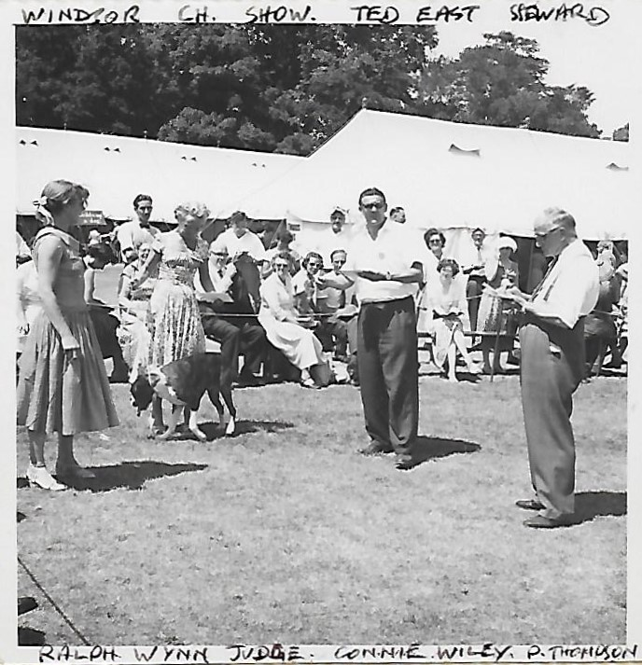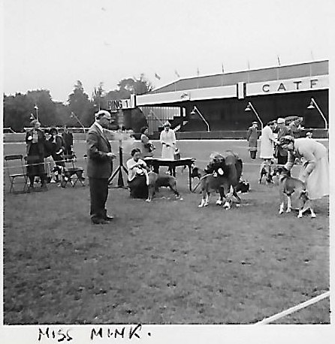 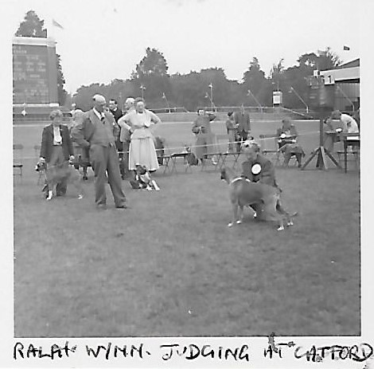

**Useful Links**

<http://www.ukboxerdogs.co.uk/>- a good reference for looking up champion boxer dogs of old!

<http://www.boxerpedigrees.info/search.php> - a good reference for older boxer pedigrees

<https://www.thekennelclub.org.uk/services/public/findapuppy/Default.aspx> - recommended if you are thinking of buying a puppy